



Place Your Project Title
Team Leader Name
Team Member 1
Team Member 2
Team Member 3
Team Member 4
Under the mentorship of,
M
entor
Name:
Team ID
-
xxxx
Project Objectives

- Problem Statement
- Project Overview – Introduction
- End Users
- Wow Factor in Project
- Modelling/Block Diagram/Flow of Project
- Result/outcomes
- Conclusion
- Future Perspective
Problem Statement
- Define the problem statement

Project overview - Introduction
- Define the project overview by adding text or image or video
End User
- Mention the end user who will use your app or project
Wow factor
- Mention the novelty in your project

Modelling
- Teams can add block diagram, Circuit diagram, wireframe etc
Result / Outcomes
- Teams can add Prototype level solution and Add result

Conclusion
- Mention the Conclusion of your project
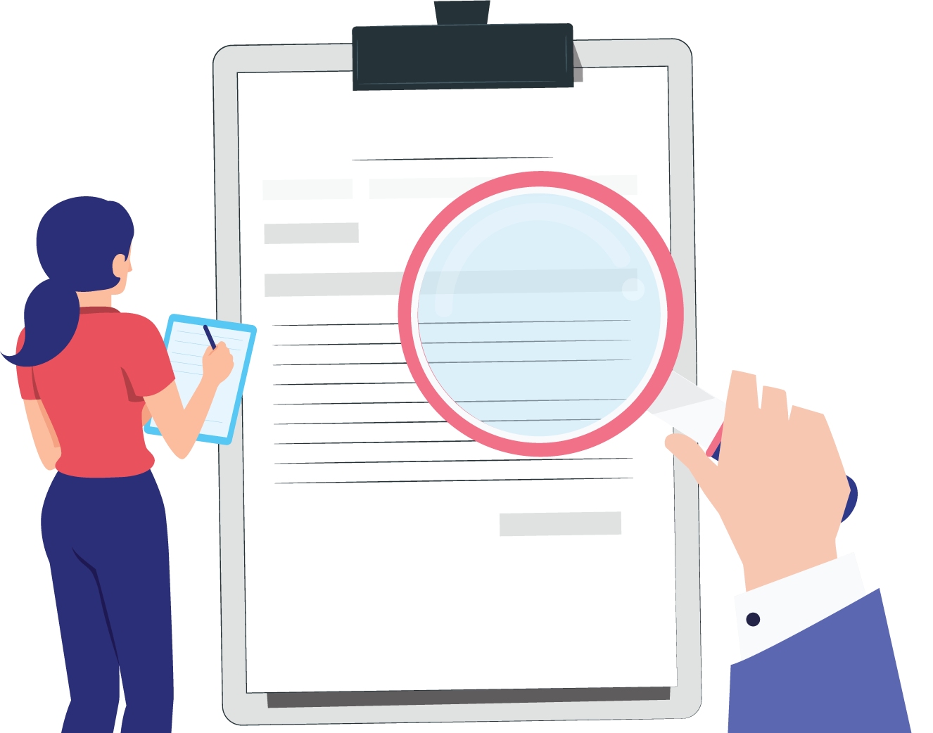
Source
https://www.freepik.com/
Future Perspective
- What features you want to add in your project in future

Thank You

